SANSKAAR PATNI
180905134 CSE C 23
OS LAB 8

1.FIBONACCI
#include <pthread.h>
#include <stdio.h>
#include <stdlib.h>
void *function(void *param)
{
int *arr = (int *)param;
int n = arr[0];
arr[0] = 0;
arr[1] = 1;
for (int i = 2; i < n; i++)
{
arr[i] = arr[i - 1] + arr[i - 2];
}
return NULL;
}

int main(int argc, char const *argv[])
{
pthread_t thread;
int n = atoi(argv[1]);
int *arr = (int *)malloc((n) * sizeof(int));
arr[0] = n;

pthread_create(&thread, 0, &function, (void *)arr);
pthread_join(thread, 0);

for (int i = 0; i < n; i++)
printf("%d ", arr[i]);
printf("\n");
return 0;
}

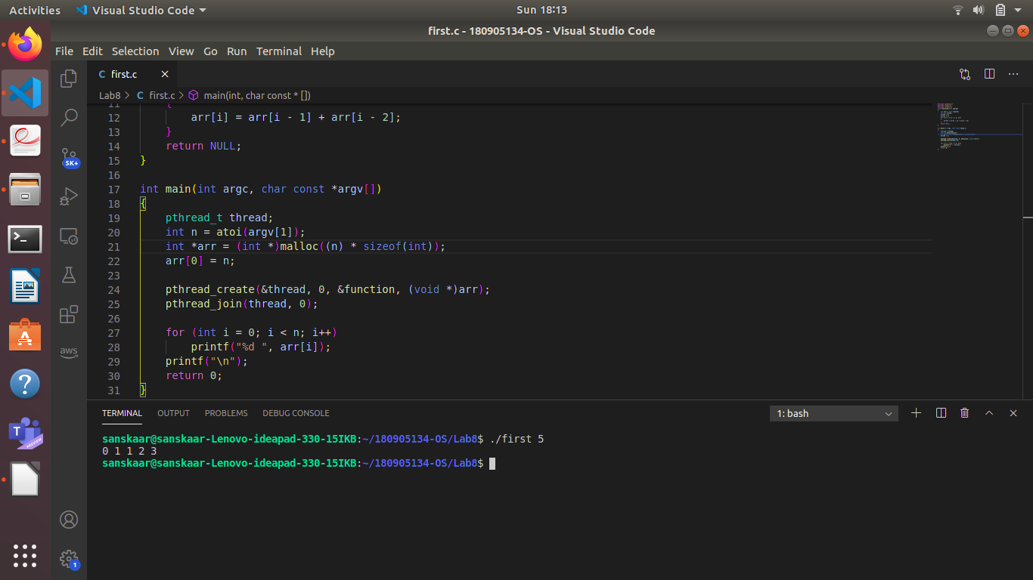
2. SUM of non negative integers
#include <pthread.h>
#include <stdio.h>
#include <stdlib.h>
void *function(void *param)
{
int *arr = (int *)param;
int n = arr[0];
int sum;
for (int i = 1; i <= n; i++)
{
sum += arr[i];
}
return (void *)sum;
}

int main(int argc, char const *argv[])
{
pthread_t thread;
int n, sum;
printf("Enter number of elements\n");
scanf("%d", &n);
int *arr = (int *)malloc((n + 1) * sizeof(int));
arr[0] = n;
for (int i = 1; i <= n; i++)
{
scanf("%d", &arr[i]);
}
pthread_create(&thread, 0, &function, (void *)arr);
pthread_join(thread, (void **)&sum);
printf("Sum is %d\n", sum);
return 0;
}
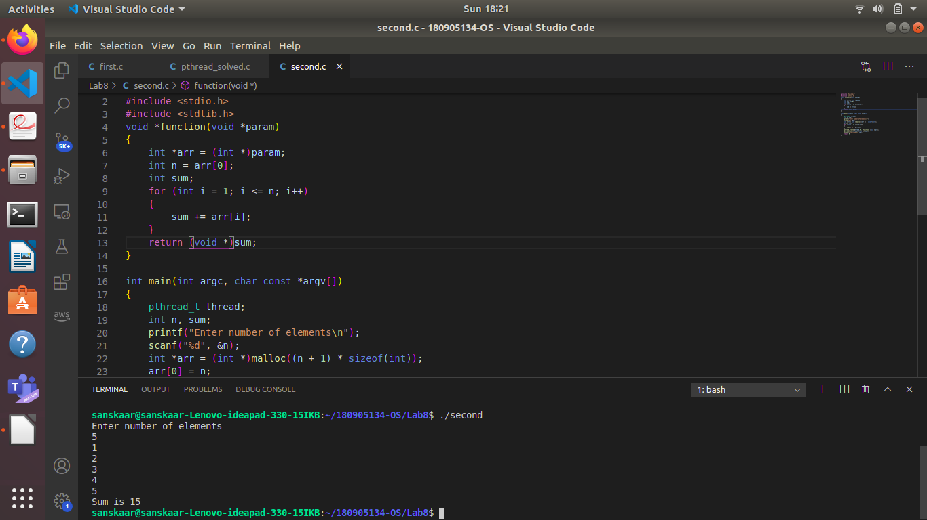
3.Prime numbers in a range
#include <stdio.h>
#include <stdlib.h>
#include <pthread.h>
#include <math.h>

#define MAX_SIZE 256

typedef struct
{
int m;
int n;
int prime_count;
int primes[MAX_SIZE];
} prime;

void *generate_primes(void *param)
{
//created a pointer to that same structure hence no need to return
prime *parameter = (prime *)param;
for (int i = parameter->m; i <= parameter->n; i++)
{
int root = sqrt(i);
int j;
for (j = 2; j <= root; j++)
{
if (i % j == 0)
break;
}
if (j == root + 1)
{
parameter->primes[parameter->prime_count] = i;
parameter->prime_count += 1;
}
}
return NULL;
}

int main()
{
prime p;
printf("Enter lower limit :\n");
scanf("%d", &(p.m));
printf("Enter upper limit :\n");
scanf("%d", &(p.n));
p.prime_count = 0;
pthread_t thread;
pthread_create(&thread, 0, &generate_primes, (void *)&p);
pthread_join(thread, NULL);
for (int i = 0; i < p.prime_count; i++)
{
printf("%d ", p.primes[i]);
}
printf("\n");
return 0;
}

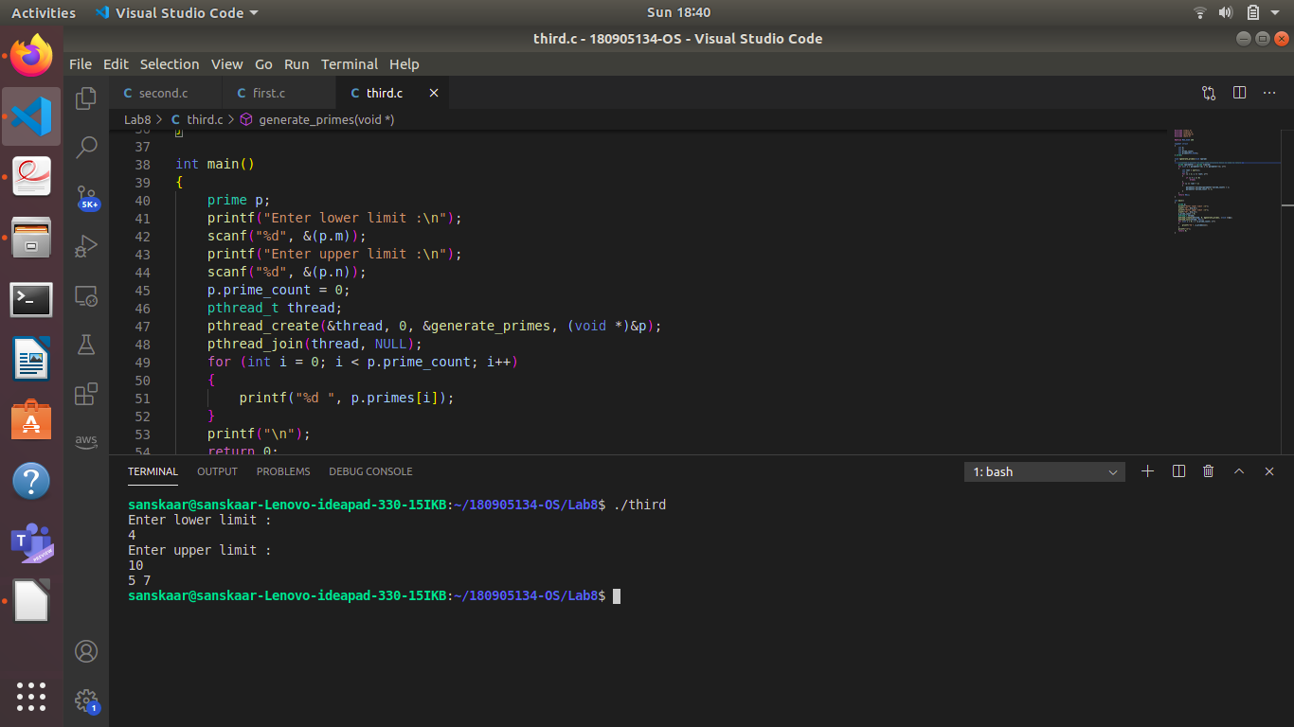
4. 2 Threads for odd and even array elements sum
#include <stdio.h>
#include <stdlib.h>
#include <pthread.h>

void *sum_odd(void *a)
{
int *arr = (int *)a;
int n = arr[0];
int sum = 0;
for (int i = 1; i < n + 1; i++)
{
if (arr[i] % 2 != 0)
sum += arr[i];
}
return (void *)sum;
}

void *sum_even(void *a)
{
int *arr = (int *)a;
int n = arr[0];
int sum = 0;
for (int i = 1; i < n + 1; i++)
{
if (arr[i] % 2 == 0)
sum += arr[i];
}
return (void *)sum;
}

int main()
{
int n;
printf("Enter the size of array:\n");
scanf("%d", &n);

int *arr = (int *)malloc(sizeof(int) * (n + 1));
arr[0] = n;
printf("Enter %d numbers:\n", n);
for (int i = 1; i < n + 1; i++)
scanf("%d", &arr[i]);

int ans1 = 0, ans2 = 0;
pthread_t thread1, thread2;
pthread_create(&thread1, NULL, &sum_odd, (void *)arr);
pthread_join(thread1, (void **)&ans1);

pthread_create(&thread2, NULL, &sum_even, (void *)arr);
pthread_join(thread2, (void **)&ans2);

printf("Odd numbers sum of array is %d\n", ans1);
printf("Even numbers sum of array is %d\n", ans2);
return 0;
}
